**SQL Database Foundations: Section 1-2**

**Task 1**

**ABC School District – Student Registration Database**

|  |  |
| --- | --- |
| Personal Information |  |
| Full Name | Last Name: First Name: Middle Name: |
| Date of Birth |  |
| Gender |  |
| Home Address | Street Address: City: State/Province: Zip code: |
| Student ID (if known) |  |
| Parent/Guardian | Full Name: Relationship to Student: Contact Number: Email Address: |
| Emergency Contact Person | Full Name: Relationship to Student: Contact Number: Email Address: |

|  |  |
| --- | --- |
| Educational and Other Additional Information |  |
| Current Grade Level |  |
| Previous School Attended  (if applicable) |  |
| Transcripts from Previous School (if applicable) |  |
| Health Record Information | Allergies (Foods/Medications): Medical Condition: (if applicable) Immunization: |
| Extracurricular Activities | Sports: Clubs/Organizations: Volunteer Work: |

|  |
| --- |
| Electronic Signature of Parent/Guardian Providing the Consent |
| I agree that by typing my full name, I acknowledge that my electronic signature is the legal equivalent of my handwritten signature.  Full Name: _______________________________________ Today’s Date: ________________ |

**Task 2**

**XYZ Community Library – Library Management Database**

|  |  |
| --- | --- |
| Customer Information |  |
| Full Name | Last Name: First Name: Middle Name: |
| Date of Birth |  |
| Library Card Number |  |
| Address | Street Address: City: State/Province: Zip code: |
| Contact Details | Contact Number: Email Address: |

|  |  |
| --- | --- |
| Book Information |  |
| Title of the Book |  |
| Author(s) |  |
| ISBN |  |
| Book Edition |  |
| Publisher |  |
| Year Published |  |
| Genre |  |

|  |  |
| --- | --- |
| To Track Daily Operations of the Library |  |
| Library Reference Number |  |
| Library Card Number of the Customer |  |
| ISBN of the book |  |
| Check out date of the book |  |
| Return date of the book |  |
| Due date of the book |  |
| Late fee after due date |  |
| Damage fee if book is damaged |  |

**SQL Database Foundations: Section 1-Exercise 3**

Exercise 1 – **Identify the Database Models**

a) Hierarchical Model

b) Network Model

c) Object-oriented Model

d) Relational Model

e) Flat File Model

**SQL Database Foundations: Section1- Exercise 4 (Business Requirements)**

**Task 1** – Identify the business rule and associated constraints from the case scenario described.

|  |  |
| --- | --- |
| Business Rules | Constraints |
| * Members will pay membership fees. | * Members can belong to one of the three types of membership (corporate, student, individual). |
| * Student membership is free. * Corporate and faculty memberships incur a fee. | * Type of membership can be changed only if sufficient justification is provided. |

**Task 2** – Identify the business rule and associated constraints from the case scenario described.

|  |  |
| --- | --- |
| Business Rules | Constraints |
| * The hospital ensures that their doctors have a minimum of seven years of working experience. | * Every doctor registered with the hospital is assigned with unique ID that starts with letter “DC”. |
| * Every patient is required to register with the hospital on their first visit. | * A unique patient number starting with the letters “PT” is assigned to patient upon arrival to the hospital. |

Next page: ‘Oracle Baseball League Store Database Answer’

Section 1 Lesson 4 Exercise: Business Requirements

Oracle Baseball League Store Database

|  |  |  |  |
| --- | --- | --- | --- |
| Note | Business Rule | Assumption | Problem |
| * When a customer places an order, the order items for a particular order are recorded in the database. | ✔︎ |  |  |
| * Teams get a discount on the list price depending on the number of players. |  | ✔︎ |  |
| * OBL has three sales representatives that officially only call on teams but have been known to handle individual customers complaints. |  | ✔︎ | ✔︎ |

**SQL Database Foundations: Section 2-Practice 1 – Relational Databases**

**Task 1: Book.com**

a) For Books **[ Foreign Key ] [ Foreign Key ]**

|  |  |  |  |  |  |
| --- | --- | --- | --- | --- | --- |
|  | ISBN | Year | Price | Author_ID | Publisher_ID |
| *[ Book_Title* ] |  |  |  |  |  |

b) For Authors

|  |  |  |  |
| --- | --- | --- | --- |
|  | Name | Address | Website_URL |
| [ *Author_ID* ] |  |  |  |

c) For Publishers

|  |  |  |  |  |
| --- | --- | --- | --- | --- |
|  | Name | Address | Phone_Number | Website_URL |
| Input the  [ *Publisher_ID* ] |  |  |  |  |

d) For the Stores’ Warehouses

|  |  |  |
| --- | --- | --- |
|  | Address | Phone_Number |
| Input the  [ *Warehouse_Code* ] |  |  |

e) For the Stores’ Warehouse Stock

|  |  |  |  |  |  |
| --- | --- | --- | --- | --- | --- |
|  | ISBN | Quantity_In-Stock | Warehouse_Code | Warehouse_Address | Phone_Number |
| Input the  [*Book_Title* ] |  |  |  |  |  |

f) For the number of copies of books stocked in different warehouses of the store.

|  |  |  |  |  |  |
| --- | --- | --- | --- | --- | --- |
|  | ISBN | Available_Copies | Warehouse_Code | Warehouse_Address | Phone_Number |
| Input the  [ *Book_Title* ] |  |  |  |  |  |

g) For Customers

|  |  |  |  |  |
| --- | --- | --- | --- | --- |
|  | Name | Address | Email | Phone_Number |
| Input the  [ *Customer_ID* ] |  |  |  |  |

h) For Customer’s Shopping Cart(s)

|  |  |  |  |  |
| --- | --- | --- | --- | --- |
|  | Shopping_Cart_ID | ISBN | Author_ID | Book_Quantity |
| Input the  [ *Customer_ID* ] |  |  |  |  |

i) For Shopping Cart Items

|  |  |  |  |  |
| --- | --- | --- | --- | --- |
|  | Shopping_Cart_ID | ISBN | Author_ID | Book_Quantity |
| Input the  [ *Customer_ID* ] |  |  |  |  |

j) For Customer’s Order Transaction Information

|  |  |  |  |  |  |  |
| --- | --- | --- | --- | --- | --- | --- |
|  | Order_ID | Email_Address | Billing_Address | Shipping_Address | Shipping_Option | Payment_Information |
| *[Customer_ID]* |  |  |  |  |  |  |

**Task 2: ABC Ltd**

a)

|  |  |  |  |  |  |  |
| --- | --- | --- | --- | --- | --- | --- |
|  | Customer_ID | Order_ID | Order_Quantity | Quantiy_In-Stock | Supplier_ID | Reorder_Level |
| [ Product_Details ]  (such as Product ID and Product Name) |  |  |  |  |  |  |

b)

|  |  |  |  |  |  |  |  |
| --- | --- | --- | --- | --- | --- | --- | --- |
|  | Customer_ID | Order_ID | Order_  Quantity | Back_Order_ID | Back_Order_Quantity | Supplier_ID | Reorder_  Level |
| [Product_Details ] |  |  |  |  |  |  |  |

c)

|  |  |  |  |  |  |
| --- | --- | --- | --- | --- | --- |
|  | Order_ID | Product_Details  (Product ID and Name) | Invoice_ID | Payment_ID | Amount_Paid  (Partial or Full) |
| *[Customer_ID]* |  |  |  |  |  |

d)

* Table A shows that for each row, it will contain the product details (product ID number and product name). For each column, it will include the customer’s ID, order ID, number of orders, available stock of each product, and supplier ID (in case ABC Ltd needs to reorder products that are low in stock). This table will make it easier for ABC to track or monitor products that are still available and those that are in low stock.
* Table B illustrates how ABC Ltd can easily monitor and manage product items ordered by customers. If any orders, are not available, they can immediately place them as back orders or re-orders, depending on the customer’s preference. Additionally, the supplier ID and re-order level are included in the columns to streamline the ordering process.
* Table C illustrates the customer’s payment information or invoice. In this table, the columns show the order ID, product details (product ID and product name), invoice ID, payment ID, and the amount paid by the customer, either partially or in full. This is important for accuracy and tracking of customer’s order details and payment which is recorded in on place, making it easier to track and manage transactions.

**SQL Database Foundations: Section 2-Practice 2 – Conceptual & Physical Data Models**

**Task 1: 5 Reasons for Creating Conceptual Model**

1) It captures a functional and informational needs of a business

2) It addresses the needs of a business

3) It identifies important entities and its relationships among those entities.

4) It is the foundation for other models that was discussed such as the logical and physical models which requires more detailed concepts.

**Task 2: Two Examples of Conceptual and Physical Models**

Conceptual Model:

* Entity relationship model
* Hierarchical model

Physical Model:

* Object-oriented model
* Relational model

**SQL Database Foundations: Section 2-Practice 3 – Entities and Attributes**

**Exercise 1: Identify and draw entities as a beginning of an ERD**

Task 1: Identify and create the **entities** for the School Management System

1) School/University

2) Department

3) Course

4) Student

5) Parent Information

6)Faculty

7) Academic Session

8) Registration

9) Enrollment

10) Student Attendance

11) Student Attendance

12) Exam Result

13) Faculty Log (login & logout times)

**Exercise 2: Identify and add Attributes and corresponding Mandatory and Optional notation to ERD**

Task 1: Add the appropriate **attributes** as well as the optionality (*, o) to all the entities of the Academic Database.

* Course:

￮ Course_ID*

￮ Course_Name*

￮ Course_Descriptiono

￮ Credit_Hours*

* Department

￮ Department_ID*

￮ Department_Name*

￮ Department_Heado

￮ Department_Locationo

* Student

￮ Student_ID*

￮ Student_First_Name*

￮ Student_Last_Name*

￮ Student_Middle_Nameo

￮ Birthdate*

￮ Sex/Gendero

￮ Addresso

￮ Phone_Numbero

￮ Email_Address*

￮ Student_Attendance*

* Faculty

￮ Faculty_ID*

￮ Department_ID*

￮ First_Name*

￮ Last_Name*

￮ Phone_Number*

￮ Email_Address*

￮ Login_Time*

￮ Logout_Time*

* Academic Session

￮ Academic_Session_ID*

￮ Session_Type*

* Parent Information

￮ Parent_ID*

￮ Parent_First_Name*

￮ Parent_Last_Name*

￮ Phone_Number*

￮ Email_Address*

* Exam

￮ Exam_ID*

￮ Course_ID*

￮ Academic_Session_ID*

￮ Exam_Date*

￮ Exam_Result*

**SQL Database Foundations: Section 2-Practice 4 – Unique Identifiers**

**Exercise 1: Identify the Unique Identifiers and the corresponding Primary Keys.**

Tasks:

1) How do you find a particular song in the whole collection? What would be a unique identifiers for SONG?

⇾ UID: Title of the Song, Artist of the Song

2) Think about all the students in the classroom. Each student is described by several traits or attributes. Which attribute or attributes allow you to pick a single student from the rest of the class?

⇾ Student_ID or Birthdate

3) For each entity, select the attribute that could be the unique identifier of each entity.

⇾ Entity – Student: Student ID

⇾ Entity – Movie: Title

⇾ Entity – Locker: Number

**Exercise 2: Identify the Unique Identifiers and add to the ERD.**

Task 1: Use the Academic Database ERD from the previous exercises to identify the following:

⇾ Unique Identifiers:

* Student ID
* Course ID
* Department ID
* Faculty ID
* Exam ID
* Parent ID

⇾ Candidate Unique Identifiers:

* Faculty Email Address

**SQL Database Foundations: Section 2-Practice 5 – Relationships Practices**

**Exercise 1: Identify relationships from the ERD**

Task 1: Which text corresponds to the diagram? ⇾ **B**

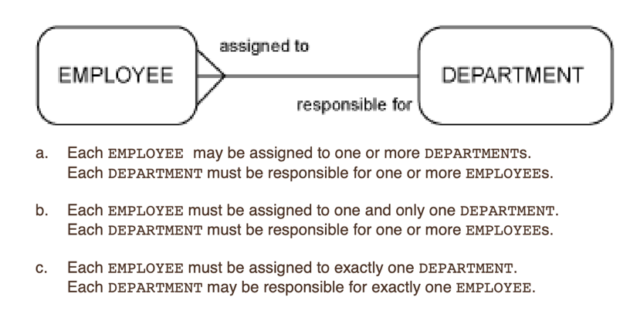

Task 2: For each relationship, write the ERD statement and your comments. Use your knowledge of normal people and towns in your comments.

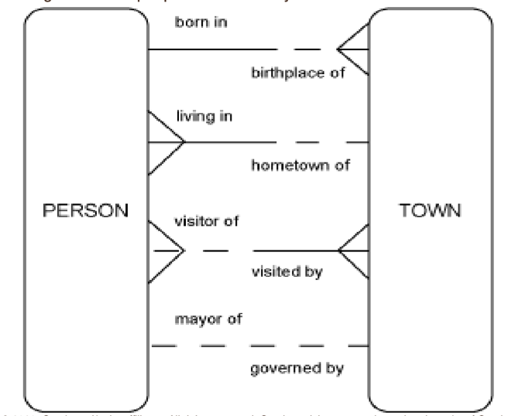

⇾ Each person must be born in one and only town. Each town may be a birthplace of one or more people.

⇾ Each person must be living in one and only town. Each town may be a hometown of one or more people.

⇾ Each person may be a visitor of one or more towns. Each town may be visited by one or more people.

⇾ Each person may be a mayor of one and only town. Each town must be governed by one and only person.

**Exercise 2: Analyze and Model Relationships**

Task 1: Write the ERDish for each of the relationships in the Academic Database including relationship names, optionality and cardinality.

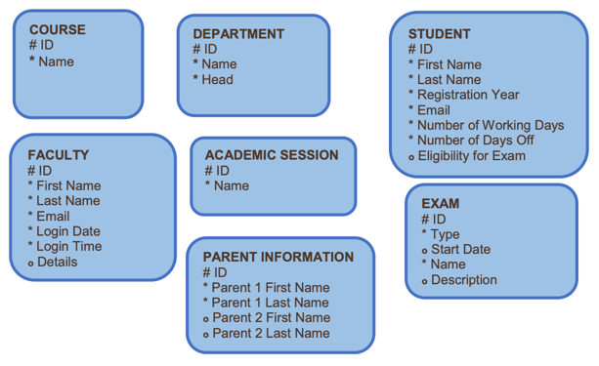

* Each course must be offered by one and only department. Each department may offer one or more courses.
* Each department may have one or more students. Each student must be enrolled in one and only department.
* Each student may be enrolled in one or more courses. Each course may have one or more students enrolled.
* Each faculty member must belong to one and only department. Each department may consist of
* one or more faculty members.
* Each course must be included in one or more academic session. Each academic session must have one or more courses.
* Each student must have one and only one parent information. Each parent information must be connected to one and only student.
* Each academic session may have one or more exams. Each exams must be given in one or more academic sessions.

**SQL Database Foundations: Section 2-Practice 6 – Entity Relationship Modeling Practices**

**Exercise 1: Identify the components in the ERD**

Task 1: Identify the possible Entities and Attributes from the given scenario. (Answer)

* Department (Entity)
* Department ID
* Department Name
* Supervisor (Entity)
* Supervisor ID
* Supervisor Name
* Employee (Entity)
* Employee ID
* Employee Name
* Project (Entity)
* Project ID
* Project Name

Task 2: Read the given business scenario. Draw the entities HAIRSTYLIST and CLIENT. List the attributes associated with each entity and specify whether they are mandatory or optional. Identify the UIDs. Follow the diagramming conventions discussed. State the ERDish for the relationships.

* Hairstylist (Entity)
* Hairstylist ID* [ UID ]
* Hairstylist First Name*
* Hairstylist Last Name*
* Addresso
* Phone Numbero
* Social Security Number*
* Salary*
* Client (Entity)
* Client ID* [ UID ]
* Client First Name*
* Client Last Name*
* Phone Number*

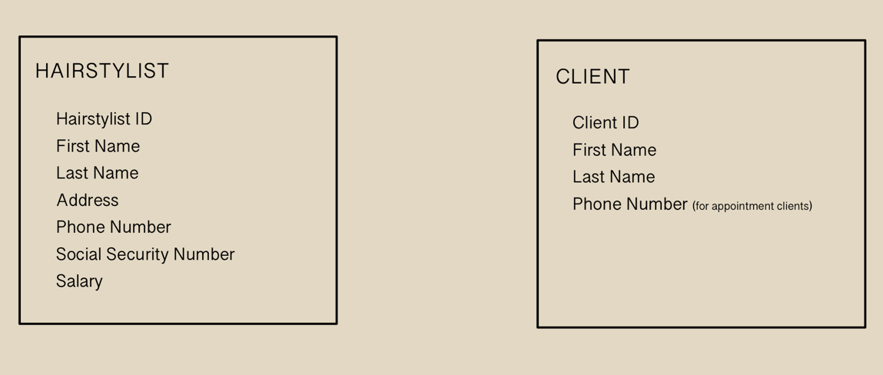

Each HAIRSTYLIST may be the stylist of one or more CLIENTs.

Each CLIENT must be attended by one and only HAIRSTYLIST on a single appointment.

Task 2: Read the given business scenario. Draw the entities TEACHER and COURSE and CLASS. List the attributes underneath each entity. Specify whether they are mandatory or optional. Identify the UIDs. State the ERDish for the relationships.

* Teacher (Entity)
* Teacher ID* [ UID ]
* Teacher First Name*
* Teacher Last Name*
* Address*
* Phone Number*
* Email Address*
* Course (Entity)
* Course ID* [ UID ]
* Course Nameo
* Class (Entity)
* Class ID* [ UID ]
* Course ID*
* Date of Classo
* Time of Classo
* Classroom Numbero

Each TEACHER may be assigned to one or more COURSEs per semester.

Each COURSE may be assigned to one or more CLASSes.

Each CLASS must be taught by one and only TEACHER.

**SQL Database Foundations: Section 3-Practice 1 – More with Relationships Practices**

**Exercise 1: Resolve M:M Relationships**

Task 1: Resolve M: M relationships between STUDENT and the COURSE using a barred relationship.

ENROLLMENT

# Student ID

# Course ID

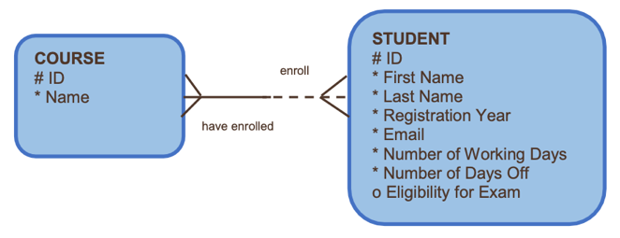

Task 2: Resolve M: M relationships between FACULTY and the COURSE.

FACULTY COURSE INFORMATION

# Faculty ID

# Course ID

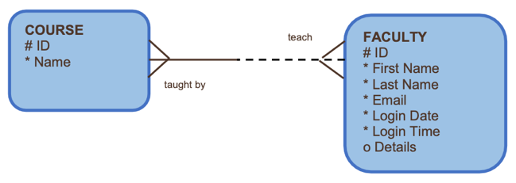

Task 3: Resolve M: M relationships between STUDENT,COURSE and EXAM.

EXAM INFORMATION

# Student ID

# Course ID

# Exam ID

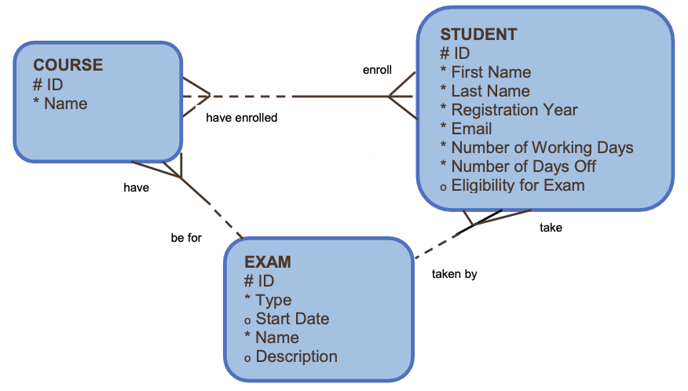

**Exercise 2: Adding nontransferability option to an ERD**

Task 1: A STUDENT will be assigned an EXAM RESULT after taking an exam. Once an EXAM RESULT has been issued, it cannot be transferred to another STUDENT.

STUDENT

EXAM RESULT

**Exercise 3: Identify and draw supertype and subtype entities**

Task 1: Faculty can be either full time or part time. Full time faculty receive a salary and are entitled to an insurance plan. Part time faculty are paid on an hourly basis and receive no benefits. Redraw the following entity as a supertype with subtype entities reflecting the new information.

FACULTY

(SUPERTYPE) (PK)

# Faculty ID

First Name*

Last Name*

Email*

Email*

Login Date*

Login Time*

Detailso

PART TIME

(SUBTYPE) (FK)

FULL TIME

(SUBTYPE) (FK)

# Faculty ID

Salary

Insurance Plan

# Faculty ID

Hourly Basis Type

No Benefits

PK – Primary FK - Foreign

**Exercise 4: Examine Exclusive Relationships (Arcs)**

Task 1: Each COURSE instance in the Academic Database can either be held ONLINE or in a SEATED location. Each SEATED location has a building name, room number and a date/time when the COURSE is offered. The ONLINE classes have a logon ID and a password required to enter the COURSE. Model this new information as an Arc in the Academic Database.

Login ID

Password

ONLINE

COURSE

Building Name

Room Number

Date

TIme

SEATED

**Exercise 5: Model Hierarchical Data**

Task 1: Model the entities, relationships, attributes, and unique identifiers for the hierarchy of a hotel. The hotel has many floors, many suites on each floor, and many rooms within each suite.

* Hotel (Entity)

Attributes:

* Hotel ID* [ UID ]
* Hotel Name*
* Hotel Address*
* Floor (Entity)

Attributes:

* Floor ID* [ UID ]
* Hotel ID*
* Floor Number
* Suite (Entity)

Attributes:

* Suite ID* [ UID ]
* Floor ID*
* Suite Number
* Room (Entity)

Attributes:

* Room ID* [ UID ]
* Suite ID*
* Floor Number*
* Room Number*

**Exercise 6: Model Hierarchical Data and Recursive Relationships**

Task 1: Develop two ERDs to represent the following situation. Develop one as a hierarchical structure and one as a recursive structure.

* Region
* Region Code* [ UID ]
* Region Name*
* District
* District Code* [ UID ]
* Region Code*
* District Name*
* Territory
* Territory Code* [ UID ]
* District Code*
* Territory Name*
* Sales Area
* Sales Area Code* [ UID ]
* Territory Code*
* Sales Area Name*
* Salesperson
* Employee ID* [ UID ]
* Salesperson First Name*
* Salesperson Last Name*
* Sales Quota
* Sales Manager or Director
* Employee ID* [ UID ]
* Sales Manager/Director First Name*
* Sales Manager/Director Last Name*

**Exercise 7: Developing a Complete ERD using Supertype/Subtypes and Arcs**

Task 1:

Supertype/Subtype

* Rental Office [Supertype] (PK)
* Office ID or Office Number [ UID ]
* Office Name
* Office Address
* Customer [Supertype] (PK)
* Customer ID [ UID ]
* Customer Type (either Individual or Company)
* Individual [Supertype] (PK)
* Customer ID [ UID ]
* First Name
* Last Name
* Home Address
* Home Phone Number
* Driver’s License Number
* Expiration Date
* Company [Supertype] (PK)
* Customer ID or Company Number [ UID ]
* Company Name
* Company Address
* Vehicle [Supertype] (PK)
* Vehicle ID [ UID ]
* Vehicle Type ID (Different Types of Vehicle has different code number/ID)
* State of Registration
* Registration Expiration Date
* Last Maintenance Date
* Rental Office Number (where vehicle was RENTED)
* Truck[Supertype] (PK)
* Vehicle ID [ UID ]
* Odometer Reading (for Mileage)
* Gas Tank Capacity
* Radio
* Trailer [Supertype] (PK)
* Vehicle ID [ UID ]
* Maximum Weight Capacity
* Rental Agreement [Supertype] (PK)
* Rental Agreement ID or Number [ UID ]
* Rental Office ID or Number
* Rental Start Date (when the vehicle was first rented)
* Duration of the Rental (Anticipated Date)
* Originating Rental Office ID (where the vehicle was rented)
* Drop-off Rental Office ID
* Customer ID
* Amount Paid Deposit
* Daily Rental Rate
* Rate Per Mile

Arcs: [I am not quite sure how to make Arc using all the information given. I tried everything, but I ended up creating my own scenario instead.]

RENTAL AGREEMENT

# Rental Agreement ID (PK)

Rental Office ID/Number (FK)

Customer ID (FK)

Rental Start Date

Original End Date

Amount Paid Deposit

Daily Rental Rate

Rate Per Mile

# Rental Extension ID (PK)

Original Rental Agreement ID (FK)

Original Rental Date

Extension Date

Additional Charges

RENTAL AGREEMENT EXTENSION

**SQL Database Foundations: Section 3-Practice 2 – Tracking Data Changes Practices**

**Exercise 1: Track Data Change over Time**

Task 1:

* Student
* Student ID #
* First Name*
* Last Name*
* Birthdate*
* Email Addresso
* Course
* Course ID #
* Course Name*
* Course Descriptiono
* Student Course Detail
* Course ID #
* Student ID #
* Grade*

Task 2: Examine the ERD that represents classroom assignments for different exams.

a. Why is start time part of the UID of ASSIGNMENT?

b. Name at least three time-related constraints.

Answer:

a) Start time is part of the assignment’s UID because it helps to distinguish assignments based on when they were given. For instance, students start their assignments at specific times and this information will helped link it to assignment(s).

b) (1) End time must be later than start time.

(2) There should be a specific maximum duration of time allowed for assignments.

(3) Assignments may only be accessible within a specific time period.

**SQL Database Foundations: Section 3-Practice 3 – Normalization and Business Rules Practices**

**Exercise 1: Relational Databases**

Task 1:

|  |  |  |
| --- | --- | --- |
| ITEM ID | COLOR | PRICE |
| IT001 | Red | $16.56 |
| IT001 | Blue | $16.56 |
| IT002 | Yellow | $17.48 |
| IT003 | Green | $19.76 |
| IT004 | Blue | $20.00 |
| IT004 | Yellow | $20.00 |

Task 2:

|  |  |
| --- | --- |
| SUPPLIER ID | STORE ID |
| SP001 | S1 |
| SP001 | S3 |
| SP002 | S1 |
| SP003 | S2 |
| SP004 | S3 |

|  |  |
| --- | --- |
| STORE ID | LOCATION |
| S1 | New York |
| S1 | New Hampshire |
| S2 | Rhode Island |
| S3 | Vermont |
| S3 | Illinois |

Task 3:

Books:

|  |  |  |
| --- | --- | --- |
| BOOK ID | CATEGORY ID | PRICE |
| 1 | 1 | $27.99 |
| 2 | 2 | $17.99 |
| 3 | 1 | $20.99 |
| 4 | 3 | $40.99 |
| 5 | 2 | $19.99 |

Categories:

|  |  |
| --- | --- |
| CATEGORY ID | CATEGORY DESCRIPTION |
| 1 | Cooking |
| 2 | Travel |
| 3 | Computers |

**Exercise 2: Normalize Academic Database ERD**

Task 1:

* Parent Information
* There must be Phone Number and Email Address.
* Student Course Detail
* Course ID # and Student ID # must be included and not just a Grade.
* Faculty
* I think Department ID, Phone Number, and a logout time must also be included.
* Student
* The number of working days/days off should not be included.
* Course
* Course Name and Credit Hours should be included
* Academic Session
* Academic Session Type instead of Name (I’m not sure what name it is referring to)
* Exam
* Course ID, Academic Session ID, Exam Date (instead of Start Date), and Exam Result should be added.
* Type (I’m not sure what is this) but I think it should not be here.
* Exam Result Entity above the Exam entity must be eliminated because Exam Result will be added under the Exam entity

**Exercise 3: Validate an ERD for Normalization**

* Professor, I was unable to complete Task 1. I really tried my best. Although I thought I understood the topic about Section 3-3, this specific table just left me very confused that my brain cannot process all the information.

Task 2:

* Car
* Car ID Number # [PK]
* Color Scheme ID* [FK]
* Make*
* Model*
* Color Scheme
* Color Scheme ID # [PK]
* Color Scheme Nameo (Desert; Sunburst)
* Paint Color* (Silver; Gold)
* Interior Color* (Gray Leather; Cream Leather)

**Exercise 4: Gather database requirements and Business Rules**

Task 1: Identify the Business Rules

1. Every book must have an ISBN. Every book must have an author and publisher.
2. Every author must have a first and last name in the database.
3. Every publisher must have a name in the database.
4. Every warehouse store must have a warehouse store code. Every warehouse may stock different books.
5. Every warehouse store must record a copy of each book.
6. Every bookstore must have a record of customer’s name, address, email address, and phone number.
7. Every customer may own several shopping carts. Every shopping cart must have a shopping cart ID.
8. Every shopping cart may have multiple copies of the same book. Every copies of each book in a shopping cart must be recorded in the database.
9. For transaction to be completed, each customer must provide a billing address, shipping address, shipping option, and payment information. Every transaction/order completion, an email notification must be sent to the customer.

Task 2: Identify if the given description can be categorized as a Structural Business rule, Procedural Business rule or Programmatic Business rule.

* All teachers in our school must possess a valid teaching certificate. – **Structural Business Rule**
* Each Department must offer a Course. – **Structural Business Rule**
* Approval of travel requests to an event must be signed by the project manager of the event. – **Procedural Business Rule**
* A customer may make numerous payments on account. – **Structural Business Rule**
* A machine operator may not work more than 10 hours in a day. – **Procedural Business Rule**
* The Rental amount in RENTAL is calculated from the Rental rate multiplied by the number of days. – **Programmatic Business Rule**
* A Customer can have zero, one or many ORDERS. – **Structural Business Rule**
* The Total cost of the RENTAL is calculated from the sum of Insurance amount, Rental amount, and Late charge. – **Programmatic Business Rule**
* A customer’s debt must not exceed the customer’s credit limit. – **Programmatic Business Rule**

**SQL Database Foundations: Section 3-Practice 4 – Data Modeling Terminology and Mapping  
Practices**

**Exercise 1**

Task 1:

1) Analysis – a. Column

2) Entity – f. Table

3) ER Model – c. Physical Design

4) Instance – e. Row

5) Primary UID – d. Primary Key

6) Relationship – b. Foreign Key

7) Secondary UID – g. Unique Key

Task 2:

a. pk – Primary Key

b. fk – Foreign Key

c. uk – Unique Key

d. * – Mandatory (No nulls allowed)

e. o – Optional (Nulls allowed)

Task 3:

a. Authors – “AUTH”

b. Publishers – “PUB”

c. Customers – “CUST”

Task 4:

* Song (Column) – Title, Description, Release Date, Type [ X ]
* Event (Column) – Title, Description, Venue, Type [ X ]
* Customer (Column) – First Name, Last Name, Phone Number, Email Address [ X ]

**Exercise 2**

Task 1:

* Parent Information
* Parent ID [ PK ]
* Parent 1 First Name
* Parent 1 Last Name
* Student Course Detail
* Course ID [ FK ]
* Student ID [FK ]
* Grade
* Department
* Department ID [ PK ]
* Department Name
* Department Head
* Faculty
* Faculty ID [ PK ]
* Department ID [ FK ]
* Faculty First Name
* Faculty Last Name
* Email
* Student
* Student ID [ PK ]
* First Name
* Last Name
* Registration Year
* Email
* Course
* Course ID [ PK ]
* Course Name
* Academic Session
* Academic Session ID [ PK ]
* Exam
* Exam ID [ PK ]
* Course ID [ FK ]
* Academic Session ID [ FK ]
* Start Date